

**B.Sc in CSE**

**SST, Bangladesh Open University**

**CSE21P8 Assignment-II**

**Elementary Programs with Java**

|  |  |
| --- | --- |
| **Submitted By** | **Submitted To** |
| Name : **Mojahidul Alam**  Student ID : 20-0-52-801-021  Course Code : CSE21P8  Course Title : Object Oriented Programming-I Lab  Signature: | **Samrat Kumar Dey**  Lecturer (Computer Science)  School of Science and Technology  Bangladesh Open University  Gazipur-1705  Signature: |
| **Date of Submission: 29 Dec 23** | |

**Question**

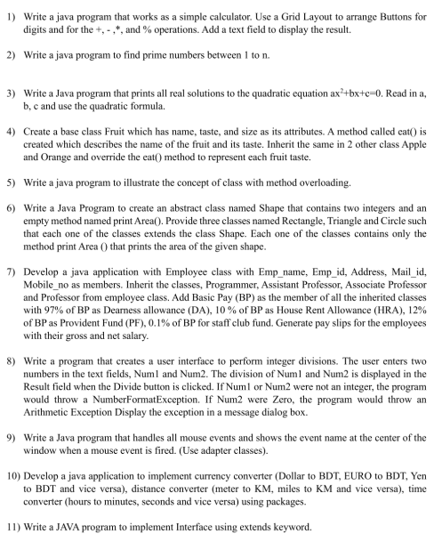

**Answer**

**2. Prime Numbers**

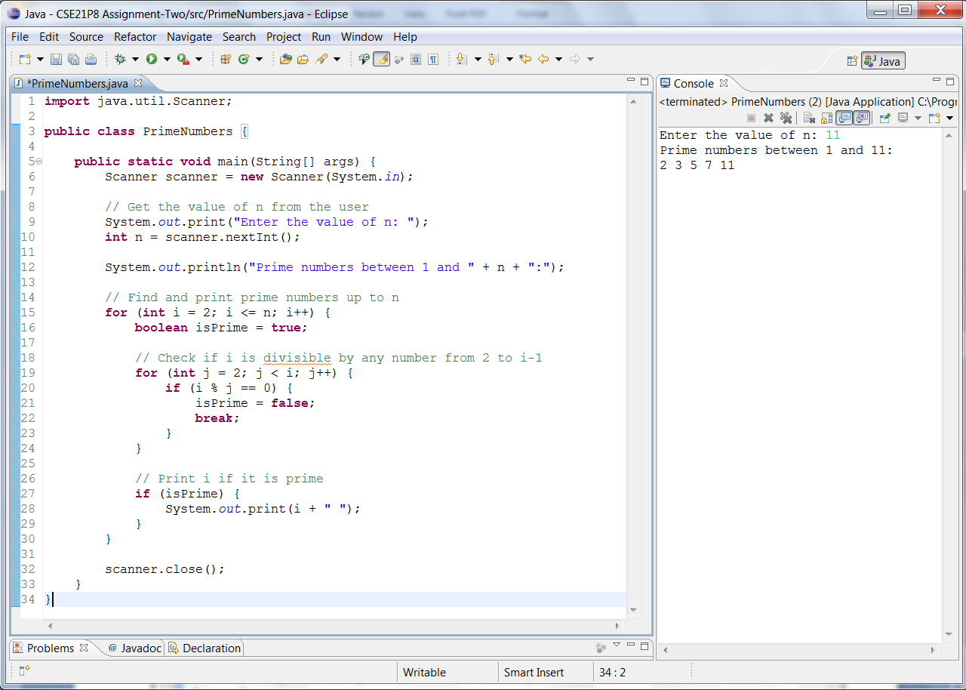

**3. Quadratic Equation Solution**

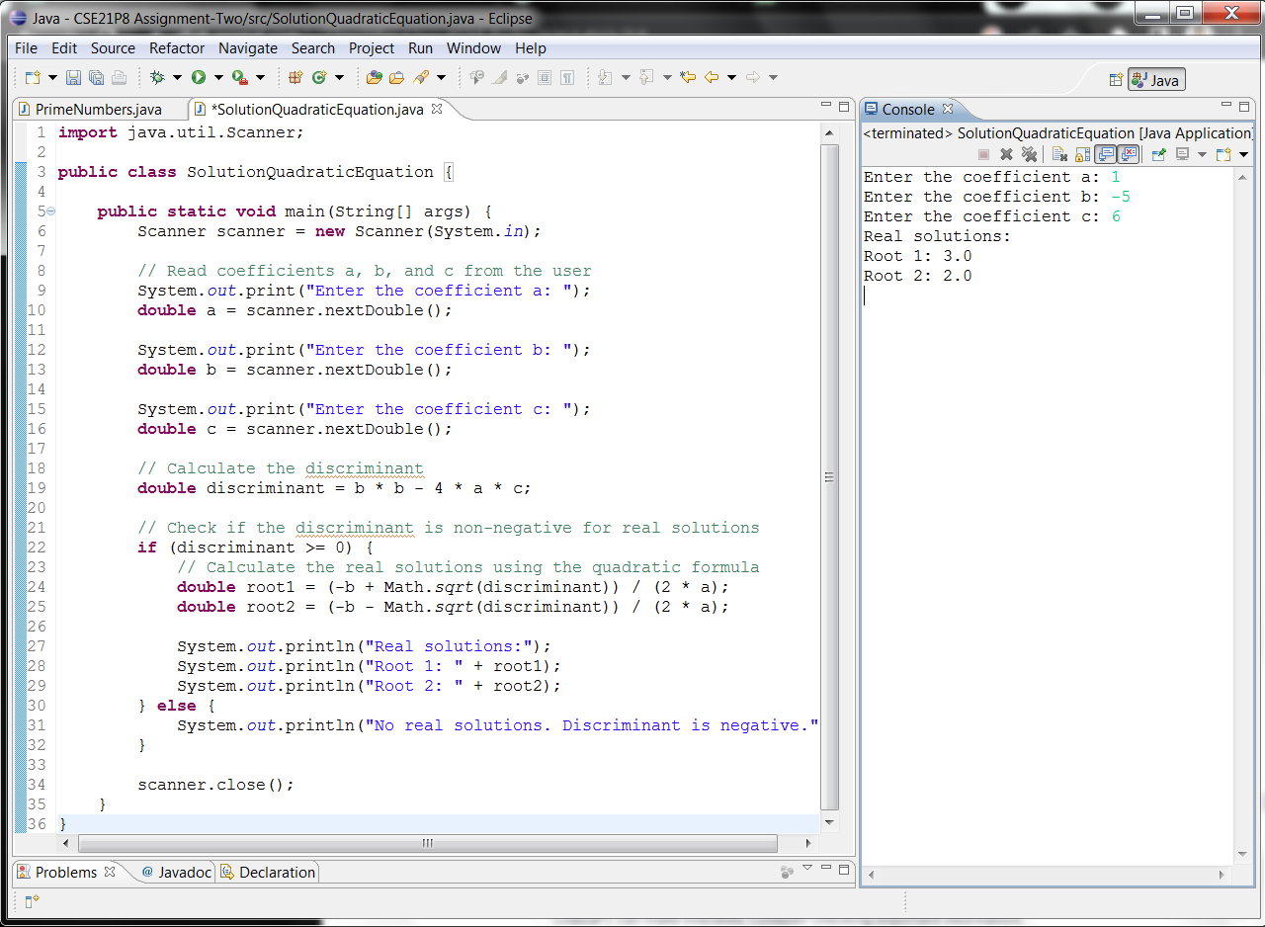

**5. Method Overloading Example**

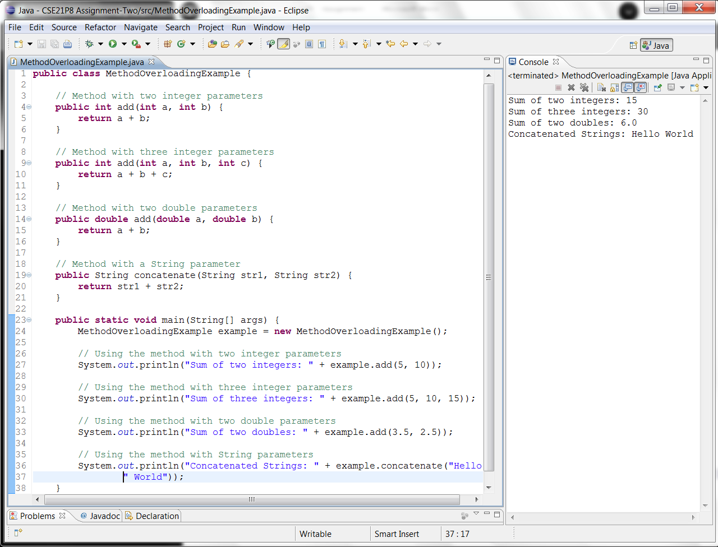

**7. Generate Pay Slip**



  